1. -- Retrieve the total number of orders placed

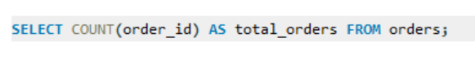

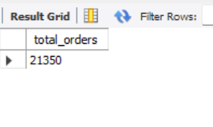

1. -- Calculate the total revenue generate from pizza sales

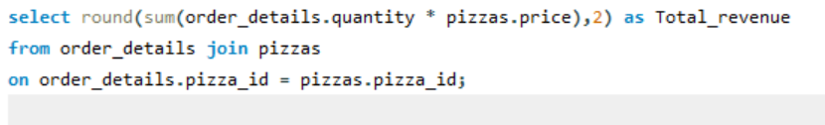

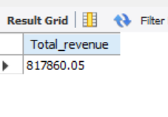

1. -- Identify the highest priced pizza

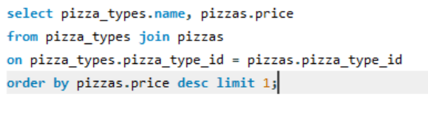

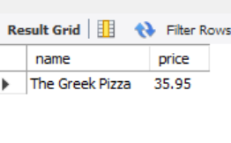

1. -- Identify the most common pizza size ordered

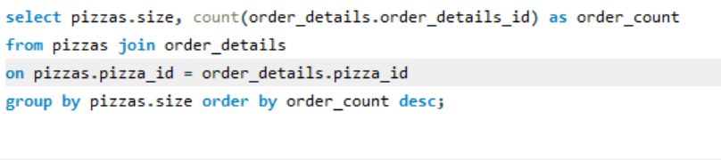

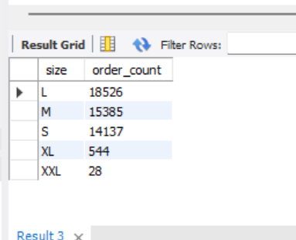

1. -- List the top 5 most ordered pizza types along with their quantity’s

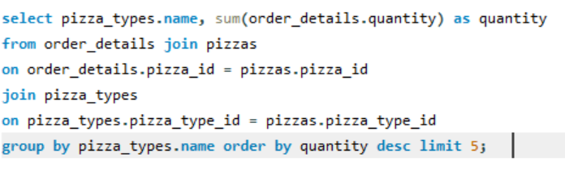

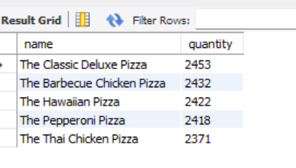

1. Join the necessary tables to find the total quantity of each pizza category ordered

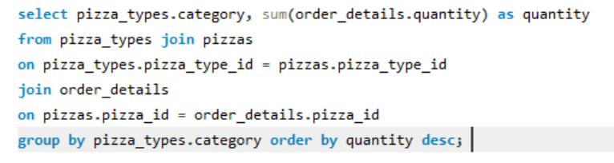

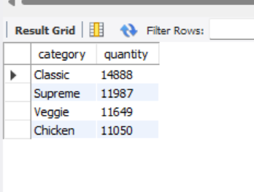

1. -- Determine the distribution of orders by hour of the day

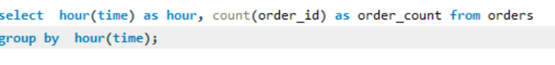

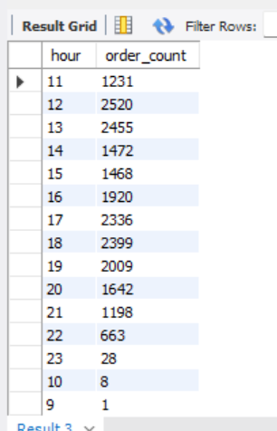

1. -- Join relevant tables to find the category wise distribution of pizzas

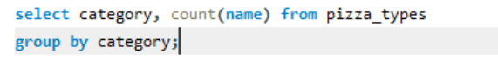

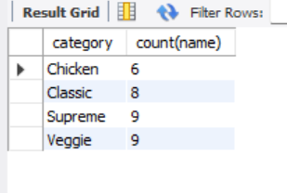

1. -- Group the orders by date and average number of pizzas ordered per day

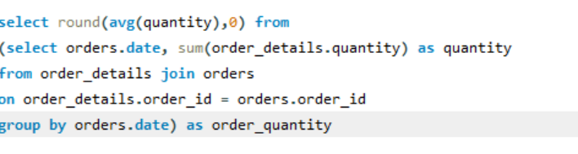

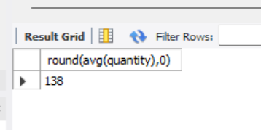

1. -- Determine the top 3 most ordered pizza types based on revenue

